**Dive into Ethereum – Clients and EVM**

Ethereum was co-founded by Vitalik Buterin and a team of co-founders including [Gavin Wood](https://www.google.com/search?rlz=1C1GCEJ_enIN1077IN1078&cs=0&sca_esv=bea007f568d2973c&sxsrf=AE3TifOig0Vx53zuEyVKyh1_F8cPjynJPA%3A1755149751503&q=Gavin+Wood&sa=X&ved=2ahUKEwiPqriryomPAxXKRWcHHUqnEOwQxccNegQIBBAC&mstk=AUtExfC_K6EIkbVFaPqP7uN1BZ55cgbiBgM8L4vul5vAA7IWA_H02GSTDNHUHg8oK3qjD2CbODdofpohCNq7S-9E0jqzq5vOg0NCOQeTN3eQUgP3CIGHD4TeHxD_-TKbHZerMqLZJtMAVNq0rfYisL0dVZTQvfCWwpaOXQcZtW5Q4z71A8TzA5n6MNHmzmKhyse39EtH51gbXXoy5aK9uqiUzi-BTjdFV0f6BaKfdS2F-SIkrf4VxC8wRE1J-xd0kkC59TUE7oNm_dqIP7yI1rZNHM6K7W6kmcAEyKcXanNxPd28mQ&csui=3), [Charles Hoskinson](https://www.google.com/search?rlz=1C1GCEJ_enIN1077IN1078&cs=0&sca_esv=bea007f568d2973c&sxsrf=AE3TifOig0Vx53zuEyVKyh1_F8cPjynJPA%3A1755149751503&q=Charles+Hoskinson&sa=X&ved=2ahUKEwiPqriryomPAxXKRWcHHUqnEOwQxccNegQIBBAD&mstk=AUtExfC_K6EIkbVFaPqP7uN1BZ55cgbiBgM8L4vul5vAA7IWA_H02GSTDNHUHg8oK3qjD2CbODdofpohCNq7S-9E0jqzq5vOg0NCOQeTN3eQUgP3CIGHD4TeHxD_-TKbHZerMqLZJtMAVNq0rfYisL0dVZTQvfCWwpaOXQcZtW5Q4z71A8TzA5n6MNHmzmKhyse39EtH51gbXXoy5aK9uqiUzi-BTjdFV0f6BaKfdS2F-SIkrf4VxC8wRE1J-xd0kkC59TUE7oNm_dqIP7yI1rZNHM6K7W6kmcAEyKcXanNxPd28mQ&csui=3), [Jeffrey Wilcke](https://www.google.com/search?rlz=1C1GCEJ_enIN1077IN1078&cs=0&sca_esv=bea007f568d2973c&sxsrf=AE3TifOig0Vx53zuEyVKyh1_F8cPjynJPA%3A1755149751503&q=Jeffrey+Wilcke&sa=X&ved=2ahUKEwiPqriryomPAxXKRWcHHUqnEOwQxccNegQIBBAE&mstk=AUtExfC_K6EIkbVFaPqP7uN1BZ55cgbiBgM8L4vul5vAA7IWA_H02GSTDNHUHg8oK3qjD2CbODdofpohCNq7S-9E0jqzq5vOg0NCOQeTN3eQUgP3CIGHD4TeHxD_-TKbHZerMqLZJtMAVNq0rfYisL0dVZTQvfCWwpaOXQcZtW5Q4z71A8TzA5n6MNHmzmKhyse39EtH51gbXXoy5aK9uqiUzi-BTjdFV0f6BaKfdS2F-SIkrf4VxC8wRE1J-xd0kkC59TUE7oNm_dqIP7yI1rZNHM6K7W6kmcAEyKcXanNxPd28mQ&csui=3), [Mihai Alisie](https://www.google.com/search?rlz=1C1GCEJ_enIN1077IN1078&cs=0&sca_esv=bea007f568d2973c&sxsrf=AE3TifOig0Vx53zuEyVKyh1_F8cPjynJPA%3A1755149751503&q=Mihai+Alisie&sa=X&ved=2ahUKEwiPqriryomPAxXKRWcHHUqnEOwQxccNegQIBBAF&mstk=AUtExfC_K6EIkbVFaPqP7uN1BZ55cgbiBgM8L4vul5vAA7IWA_H02GSTDNHUHg8oK3qjD2CbODdofpohCNq7S-9E0jqzq5vOg0NCOQeTN3eQUgP3CIGHD4TeHxD_-TKbHZerMqLZJtMAVNq0rfYisL0dVZTQvfCWwpaOXQcZtW5Q4z71A8TzA5n6MNHmzmKhyse39EtH51gbXXoy5aK9uqiUzi-BTjdFV0f6BaKfdS2F-SIkrf4VxC8wRE1J-xd0kkC59TUE7oNm_dqIP7yI1rZNHM6K7W6kmcAEyKcXanNxPd28mQ&csui=3), [Amir Chetrit](https://www.google.com/search?rlz=1C1GCEJ_enIN1077IN1078&cs=0&sca_esv=bea007f568d2973c&sxsrf=AE3TifOig0Vx53zuEyVKyh1_F8cPjynJPA%3A1755149751503&q=Amir+Chetrit&sa=X&ved=2ahUKEwiPqriryomPAxXKRWcHHUqnEOwQxccNegQIBBAG&mstk=AUtExfC_K6EIkbVFaPqP7uN1BZ55cgbiBgM8L4vul5vAA7IWA_H02GSTDNHUHg8oK3qjD2CbODdofpohCNq7S-9E0jqzq5vOg0NCOQeTN3eQUgP3CIGHD4TeHxD_-TKbHZerMqLZJtMAVNq0rfYisL0dVZTQvfCWwpaOXQcZtW5Q4z71A8TzA5n6MNHmzmKhyse39EtH51gbXXoy5aK9uqiUzi-BTjdFV0f6BaKfdS2F-SIkrf4VxC8wRE1J-xd0kkC59TUE7oNm_dqIP7yI1rZNHM6K7W6kmcAEyKcXanNxPd28mQ&csui=3), and [Anthony Di Iorio](https://www.google.com/search?rlz=1C1GCEJ_enIN1077IN1078&cs=0&sca_esv=bea007f568d2973c&sxsrf=AE3TifOig0Vx53zuEyVKyh1_F8cPjynJPA%3A1755149751503&q=Anthony+Di+Iorio&sa=X&ved=2ahUKEwiPqriryomPAxXKRWcHHUqnEOwQxccNegQIBBAH&mstk=AUtExfC_K6EIkbVFaPqP7uN1BZ55cgbiBgM8L4vul5vAA7IWA_H02GSTDNHUHg8oK3qjD2CbODdofpohCNq7S-9E0jqzq5vOg0NCOQeTN3eQUgP3CIGHD4TeHxD_-TKbHZerMqLZJtMAVNq0rfYisL0dVZTQvfCWwpaOXQcZtW5Q4z71A8TzA5n6MNHmzmKhyse39EtH51gbXXoy5aK9uqiUzi-BTjdFV0f6BaKfdS2F-SIkrf4VxC8wRE1J-xd0kkC59TUE7oNm_dqIP7yI1rZNHM6K7W6kmcAEyKcXanNxPd28mQ&csui=3). While Buterin is widely recognized as the primary visionary and author of the [Ethereum whitepaper](https://www.google.com/search?rlz=1C1GCEJ_enIN1077IN1078&cs=0&sca_esv=bea007f568d2973c&sxsrf=AE3TifOig0Vx53zuEyVKyh1_F8cPjynJPA%3A1755149751503&q=Ethereum+whitepaper&sa=X&ved=2ahUKEwiPqriryomPAxXKRWcHHUqnEOwQxccNegQIBRAB&mstk=AUtExfC_K6EIkbVFaPqP7uN1BZ55cgbiBgM8L4vul5vAA7IWA_H02GSTDNHUHg8oK3qjD2CbODdofpohCNq7S-9E0jqzq5vOg0NCOQeTN3eQUgP3CIGHD4TeHxD_-TKbHZerMqLZJtMAVNq0rfYisL0dVZTQvfCWwpaOXQcZtW5Q4z71A8TzA5n6MNHmzmKhyse39EtH51gbXXoy5aK9uqiUzi-BTjdFV0f6BaKfdS2F-SIkrf4VxC8wRE1J-xd0kkC59TUE7oNm_dqIP7yI1rZNHM6K7W6kmcAEyKcXanNxPd28mQ&csui=3), the project's development and success were a collaborative effort.

**Ethereum:**

* Ethereum is a blockchain with a computer embedded in it.
* It is the foundation for building apps and organizations in a decentralized, permissionless, censorship-resistant way.
* In the Ethereum universe, there is a single, canonical computer (called the Ethereum Virtual Machine, or EVM) whose state everyone on the Ethereum network agrees on.
* Everyone who participates in the Ethereum network (every Ethereum node) keeps a copy of the state of this computer.
* Additionally, any participant can broadcast a request for this computer to perform arbitrary computation.
* Whenever such a request is broadcast, other participants on the network verify, validate, and carry out ("execute") the computation.
* This execution causes a state change in the EVM, which is committed and propagated throughout the entire network.
* Requests for computation are called transaction requests; the record of all transactions and the EVM's present state gets stored on the blockchain, which in turn is stored and agreed upon by all nodes.
* **Ethereum client** is a software that:
* Implements the Ethereum protocol.
* Connects to other nodes in the network.
* Verifies and propagates transactions.
* Maintains the blockchain state.
* Allows developers/users to interact with the blockchain via RPC APIs.

Think of it as:

The “browser” for the Ethereum network — without it, you can’t see or interact with the blockchain.

* **Types of Ethereum Clients:**

Ethereum has multiple client implementations — all follow the same protocol but are written in different languages.

Execution Clients (EVM-focused)

* Geth (Go Ethereum) — written in Go.
* Nethermind — written in C#.
* Besu — Java-based.
* Erigon — Go-based, optimized for archival nodes.

They execute transactions, maintain state, and run the EVM.

* **Consensus Clients (Proof-of-Stake era)**

Since The Merge (2022), Ethereum uses two layers:

* Execution layer (runs the EVM, processes transactions).
* Consensus layer (validates blocks, runs PoS).

Consensus clients:

* Prysm — Go.
* Lighthouse — Rust.
* Teku — Java.
* Nimbus — Nim.

These talk to execution clients via Engine API (secured with JWT tokens).

* **EVM – Ethereum Virtual Machine**

The EVM is:

* A runtime environment that executes smart contract code.
* Deterministic: given the same inputs, all nodes get the same output.
* Stack-based architecture.
* Works with EVM bytecode compiled from Solidity, Vyper, etc.
* Runs in an isolated sandbox (no direct access to OS, file system, or internet).

**Key EVM Features**

* Gas model: Each computation costs “gas” to prevent infinite loops & spam.
* Deterministic execution: All nodes run the same operations for consensus.
* State management:
  + Account state (balances, nonces, code, storage).
  + World state (global mapping of addresses → account data).
* **How Clients and EVM Work Together**

Flow of a transaction:

1. User/DApp sends transaction and Execution client receives it.
2. Execution client:
   * Verifies transaction (signature, nonce, gas).
   * Executes it in EVM.
   * Updates state (balances, storage, contract code).
3. Execution client passes block info to Consensus client.
4. Consensus client:
   * Runs Proof-of-Stake validation.
   * Finalizes block on-chain.

**Ether:**

* Ether (ETH) is the native cryptocurrency of Ethereum.
* The purpose of ETH is to allow for a market for computation. Such a market provides an economic incentive for participants to verify and execute transaction requests and provide computational resources to the network.
* Any participant who broadcasts a transaction request must also offer some amount of ETH to the network as a bounty.
* The network will burn part of the bounty and award the rest to whoever eventually does the work of verifying the transaction, executing it, committing it to the blockchain, and broadcasting it to the network.
* The amount of ETH paid corresponds to the resources required to do the computation.
* ETH is also used to provide crypto-economic security to the network in three main ways:

1) it is used as a means to reward validators who propose blocks or call out dishonest behavior by other validators;

2) It is staked by validators, acting as collateral against dishonest behavior—if validators attempt to misbehave their ETH can be destroyed;

3) it is used to weigh 'votes' for newly proposed blocks, feeding into the fork-choice part of the consensus mechanism.

**Geth Installation Process :**

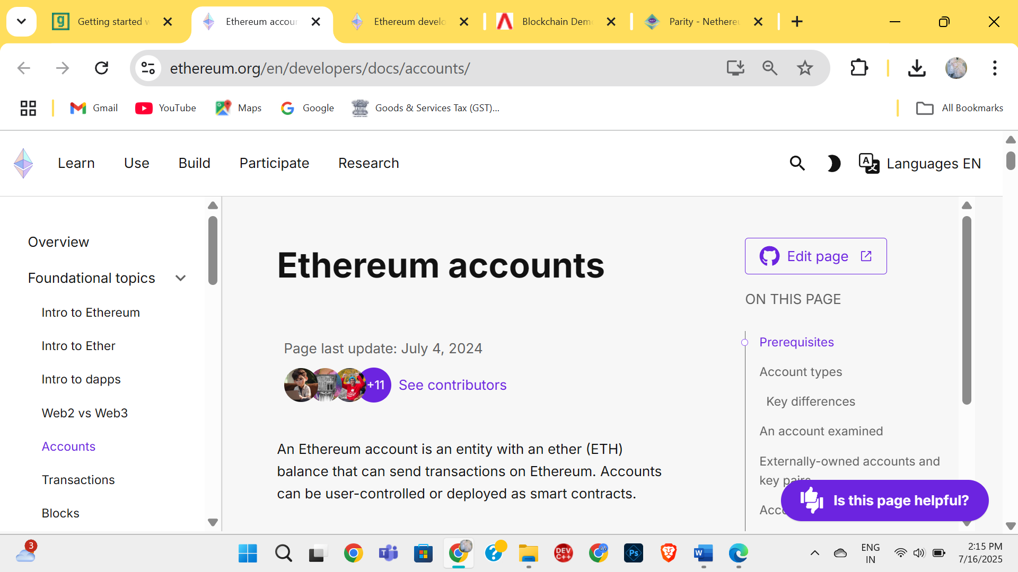

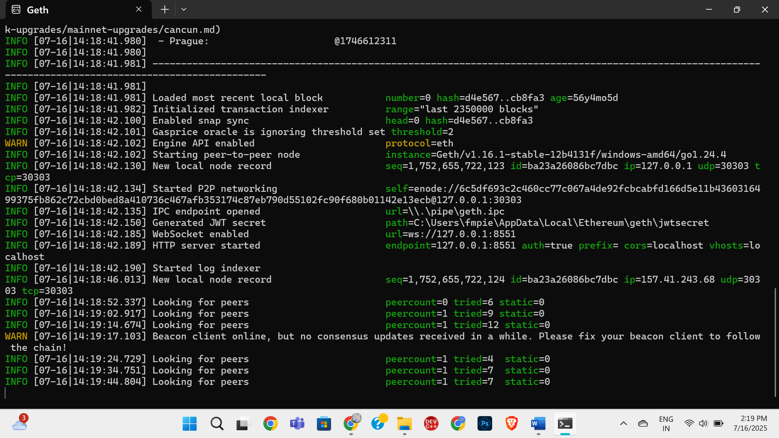

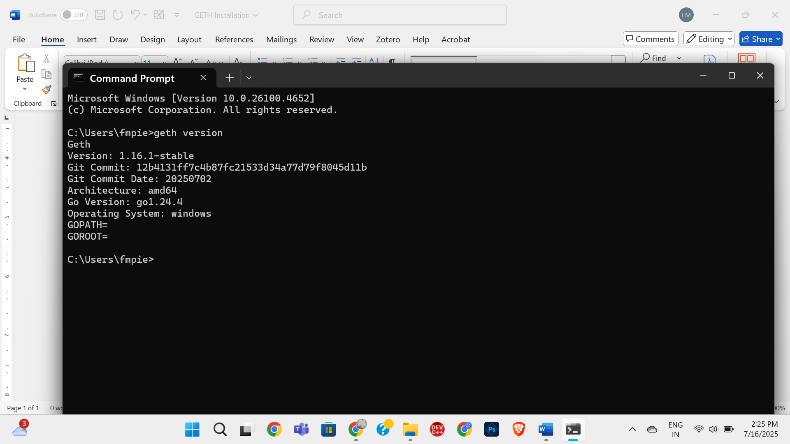

**Getting started with Geth**

Step 1: Generating accounts:

clef newaccount --keystore geth-tutorial/keystore

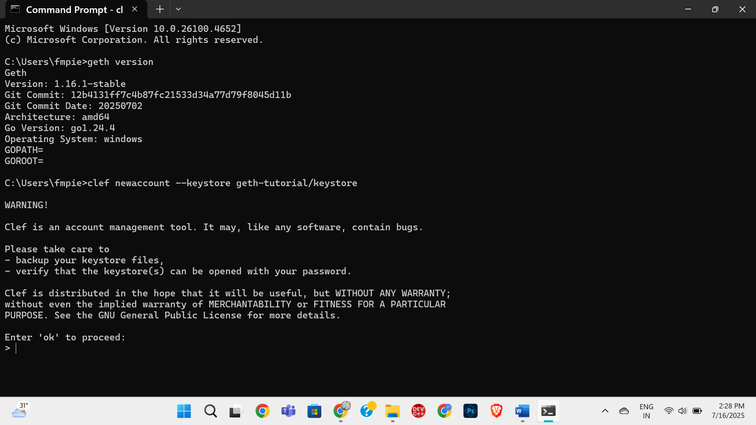

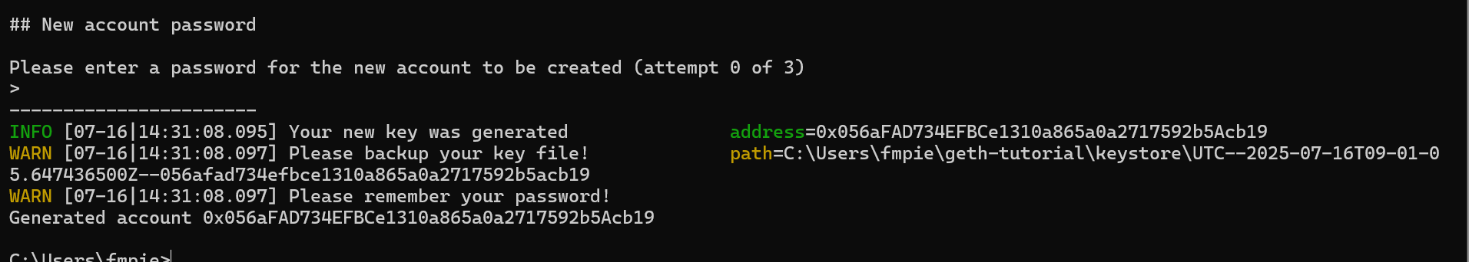

**Step 2: Start Clef:**

clef --keystore geth-tutorial/keystore --configdir geth-tutorial/clef --chainid 11155111

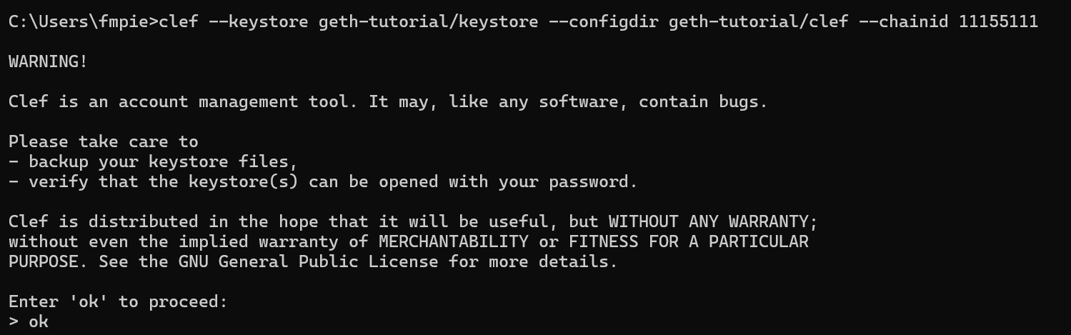

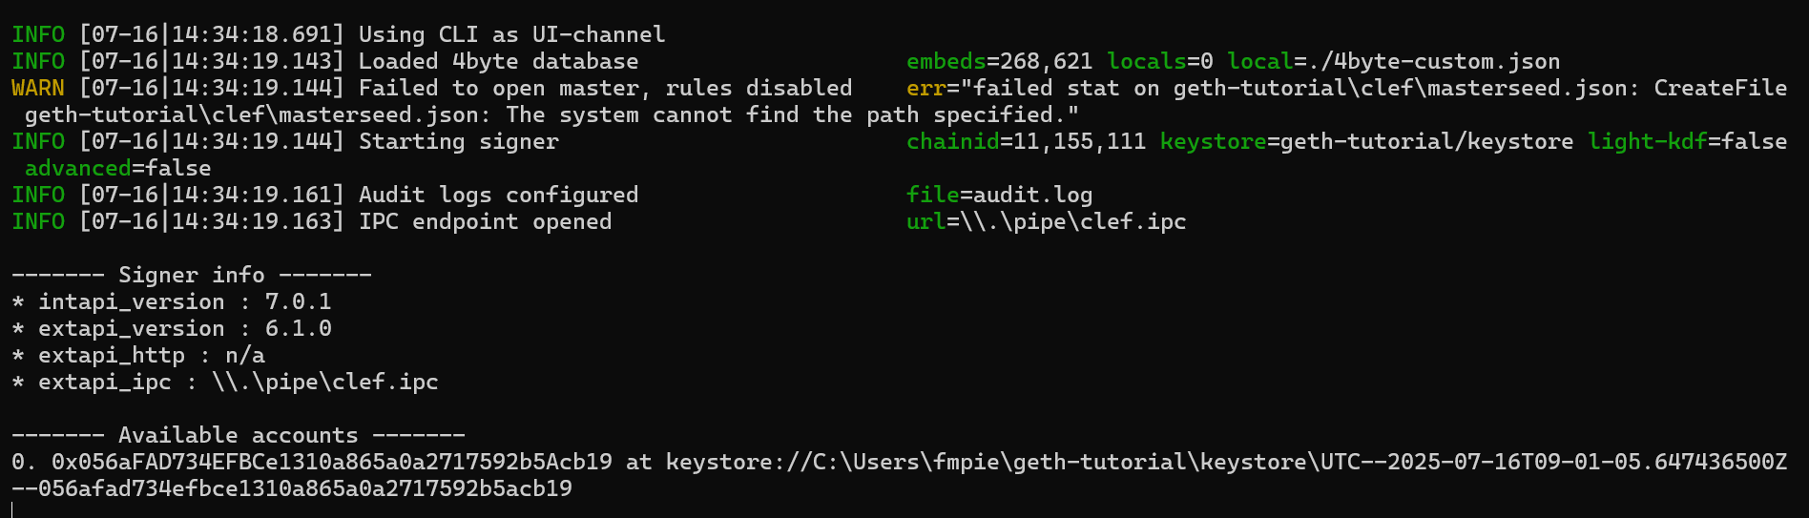

**Step 3: Start Geth:**

geth --sepolia --datadir geth-tutorial --authrpc.addr localhost --authrpc.port 8551 --authrpc.vhosts localhost --authrpc.jwtsecret geth-tutorial/jwtsecret --http --http.api eth,net --signer=geth-tutorial/clef/clef.ipc --http

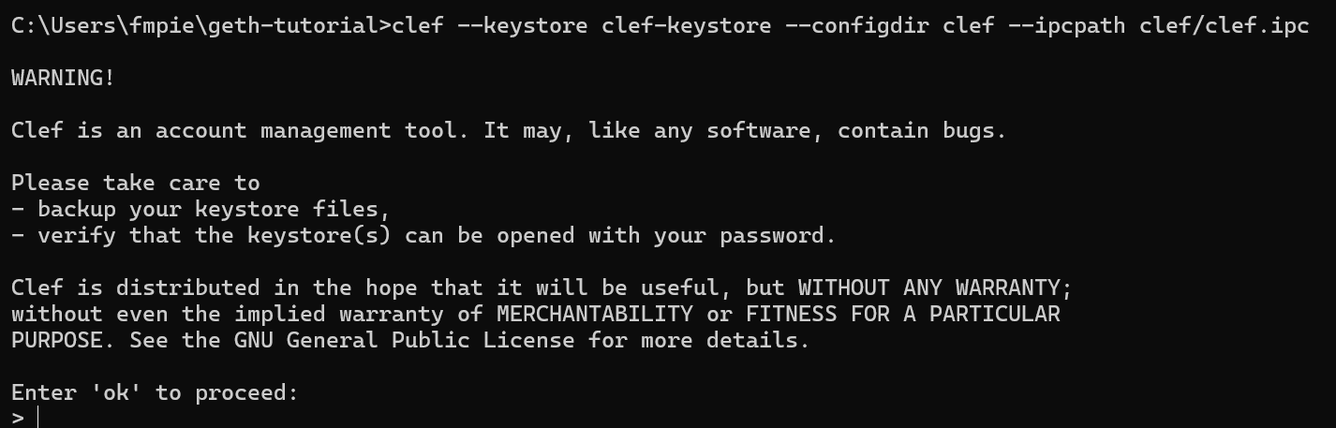

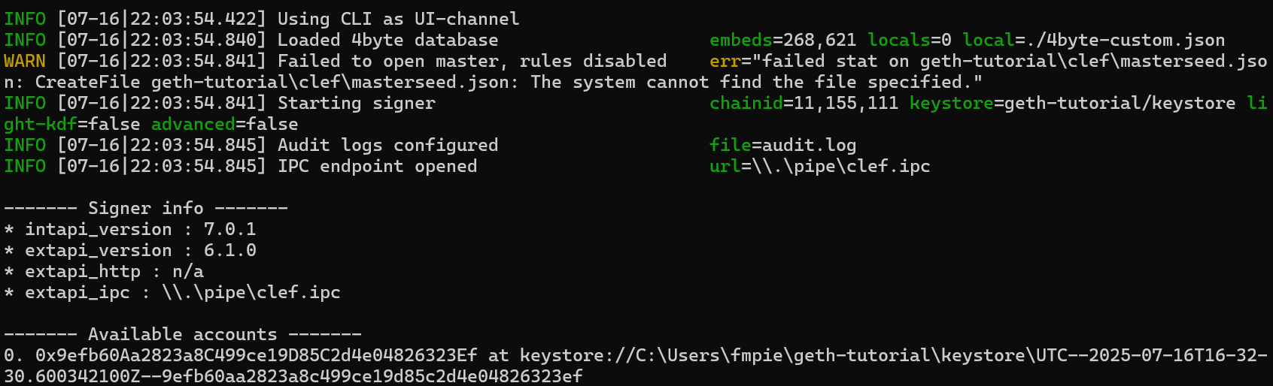

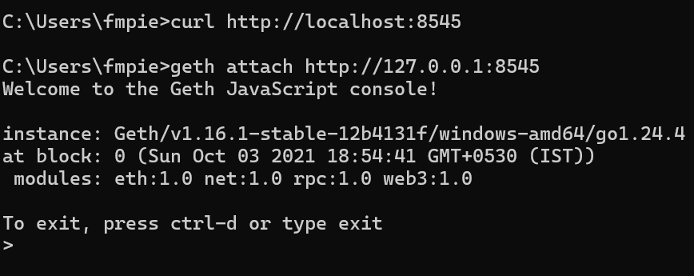

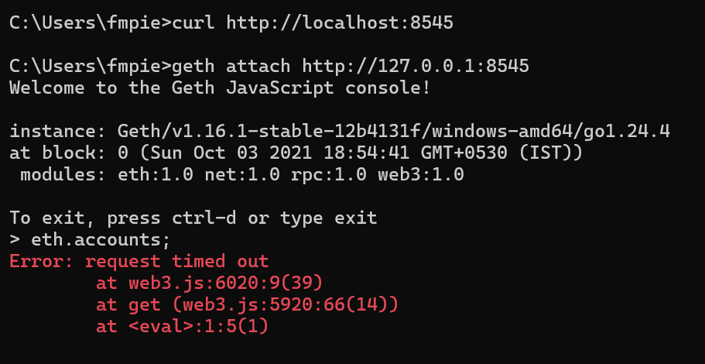

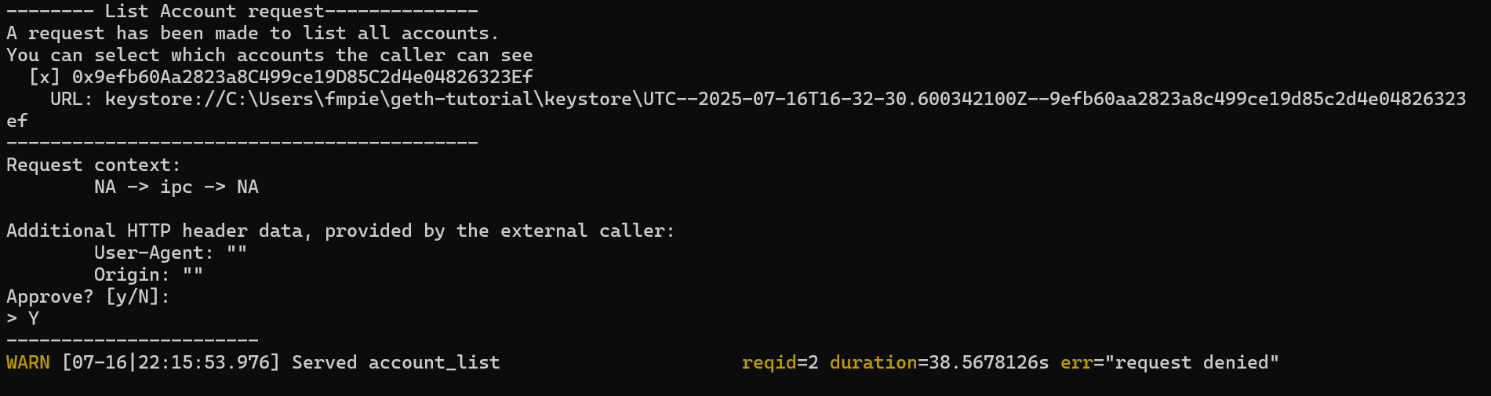

**Step 4: Get Testnet Ether**

**Step 5: Interact with Geth:**

geth attach http://127.0.0.1:8545

**List of accounts:**

eth.accounts;



